RECIPE  
Spicy Beef Green Sauce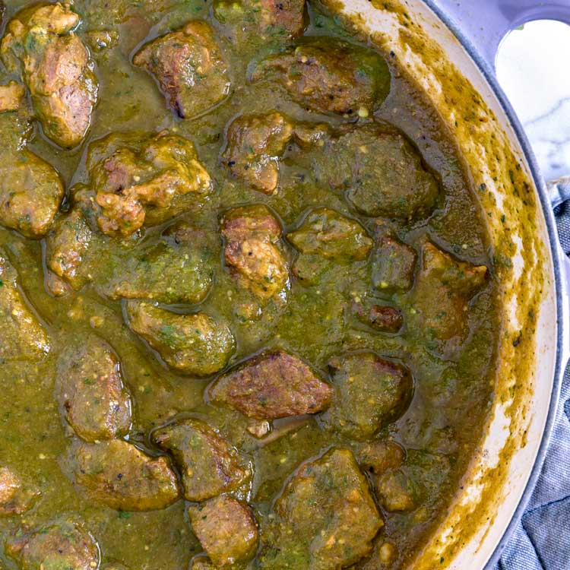

# Ingredients

* 1 - 7 oz can serrano peppers w/ stems off
* 3 cloves garlic
* ½ medium onion
* 1 tsp pepper
* 1 tsp oregano
* 1 tsp salt
* 2 tsp cumin
* 2 splashes vinegar
* ⅓ cup water
* chuck roast

# Preparation

1. Add together serrano peppers, garlic, onion, pepper, salt, oregano, cumin, vinegar, and water into a blender and blend
2. Put in pot with roast and simmer until meat is tender